**1. Query execution**

Fantastic work on using COUNT and DISTINCT! Now that we've flexed our SQL muscle a bit, we'll take a small step back and better understand how SQL code works.

**2. Order of execution**

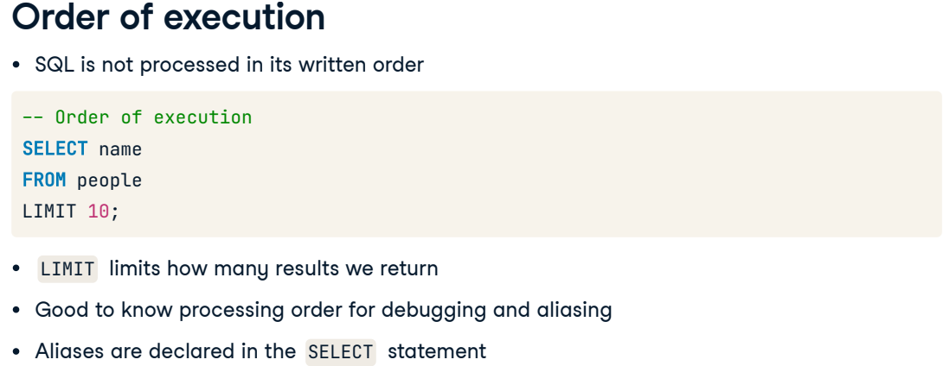Unlike many programming languages, SQL code is not processed in the order it is written. Consider we want to grab a coat from a closet: first, we need to know which closet contains the coats. This is similar to the FROM statement, which is the first line to be processed. Before any data can be selected, the table from which the data will be selected needs to be indicated. Next, our SELECTion is made. Finally, the results are refined. Here we use the LIMIT keyword that limits the results to a specified number of records. In this case, we only want to return the first ten names from the people table. Knowing processing order is especially useful when debugging and aliasing fields and tables. Suppose we need to refer to an alias later on in our code. In that case, that alias will only make sense to a processor when its declaration in the SELECT statement is processed before the alias reference is made elsewhere in the query.

**3. Debugging SQL**

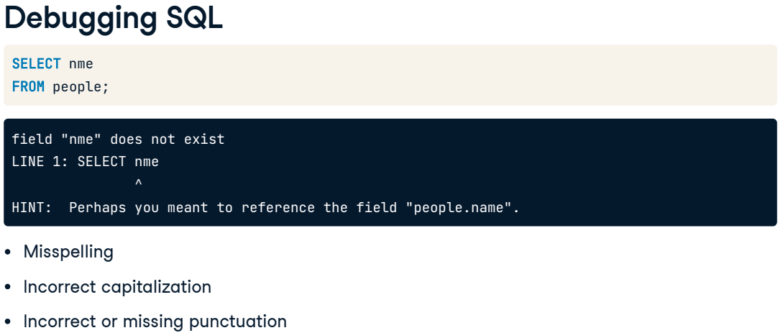Before we begin working with more advanced queries, it's useful to know more about debugging SQL code and how to read the error messages. Some messages are extremely helpful, pinpointing and even suggesting a solution for the error, as this message does when we misspell the "name" field we'd like to select. Other common errors may involve incorrect capitalization or punctuation.

**4. Comma errors**

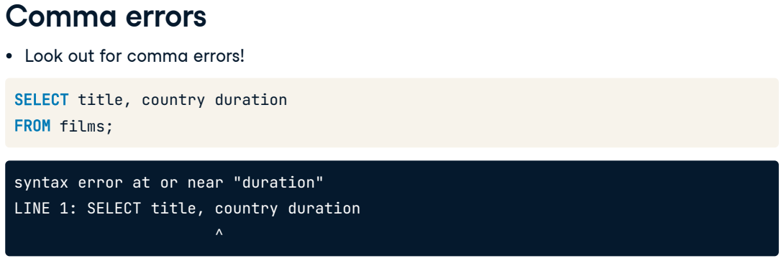Other error messages are less helpful and require us to review our code more closely. Forgetting a comma is a very common error. Let's say we've drafted this code to find all titles, country of origin, and duration of films. The error message will alert us to the general location of the error using a caret below the line of code, which in this case points to the "country" field name. We must examine the code a little further, though, to discover the missing comma is between "country" and "duration".

**5. Keyword errors**

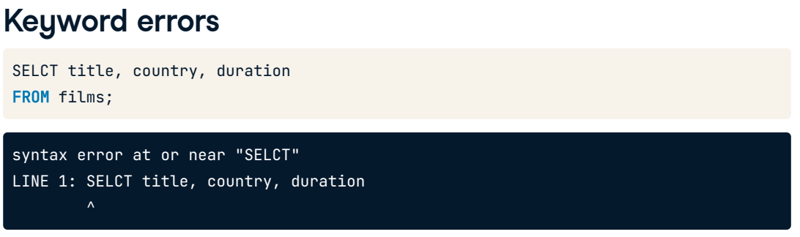SQL displays a similar error message when a keyword is misspelled, but this time, the caret indicator below the offending line is spot on.

**6. Final note on errors**

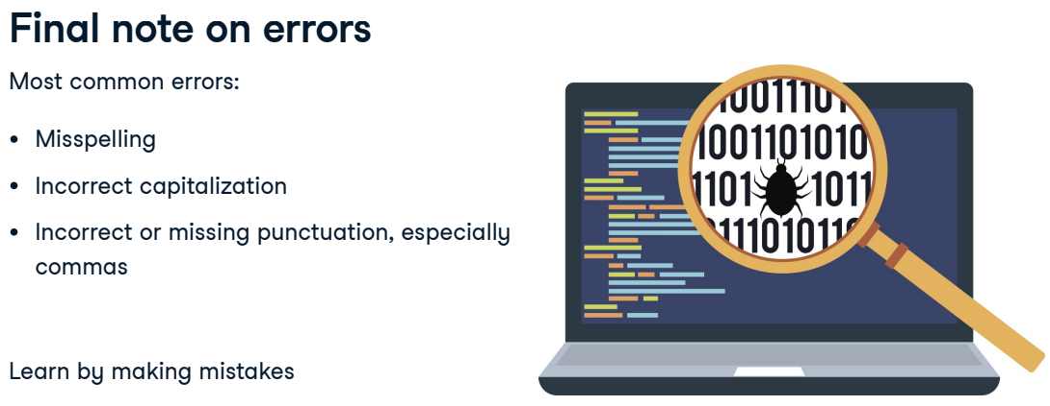There are a few more SQL errors out there, but the three mentioned in this lesson will be the most common ones we will encounter. Debugging is a major skill, and the best way to master this skill is to make mistakes and learn from them.

**7. Let's practice!**

Let's practice!

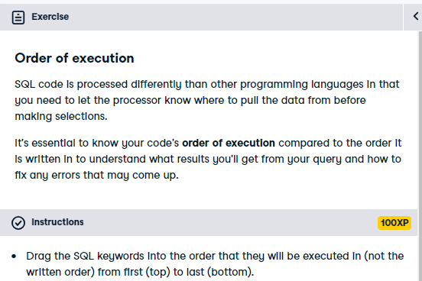



Congratulations! This is the correct order of execution. It makes sense that SQL needs to know where to SELECT data FROM before it can LIMIT the results.

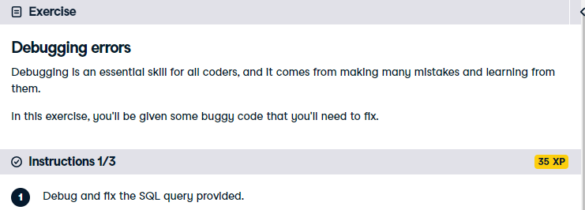

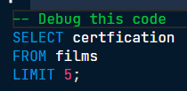

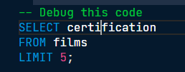



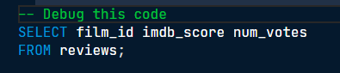

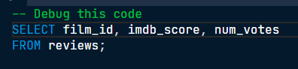



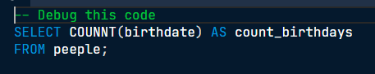

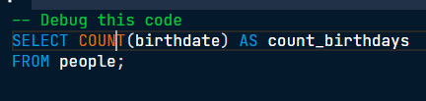

Excellent extermination of those bugs! This is an important skill that will come in very handy.